**Functional Document**

|  |  |
| --- | --- |
| **Application** | NGERP - Centra |
| **Service Bundle** | Purchase Management |
| **Service Request** | NTA Receipt Allocation |

**Description :**

NTA Receipt Allocation screen is used to allocate the NTA AR invoice and NTA Receipt. User have to choose the businesspartner to whom they wish to allocate the invoice and the payment.

**Workflow Process :**

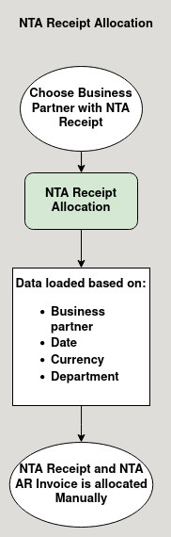

**Business Rules :**

* NTA Receipt Allocation screen can be only accessed in HQ.
* This screen is used to allocate NTA AR invoice and NTA Receipt.
* NTA AR invoice document with completed status is shown in invoice tab.
* The data loaded in this tabs are based on:
  + Business Partner
  + Date
  + Currency
  + Department
* These are chosen by the user.
* NTA Receipt document with completed status in Payment tab.
* User should choose the business partner to whom they want to allocate the payment.
* User can only able to manually allocate the NTA AR Invoice with the NTA Receipt.
* User can allocate partial or full payment to the NTA AR invoice.
* The allocated payment can be viewed in the view allocation tab.